Name: _____________________

Astronomy 102 Lab: Distances to Galaxies

You will access your textbook for this lab.

Pre-Lab Assignment: As we began to talk about stars beyond the Sun, one of the most important pieces of information we needed to know about these objects was their distances. Our estimates of their distances strongly affect our determination of properties like the stars' luminosity, size, and mass (mostly for binary stars). Without solid distance determining methods for nearby stars, we would understand far less about stars. In this lab, you will be learning about several methods which are used to determine the distances to galaxies. Answer the following questions before coming to lab.

A) Name and describe a method for finding the distances to stars. Why can't this method be used to determine the distances to galaxies?

Look at the figure below. Let's say that this is the light curve for a star whose brightness varies regularly.

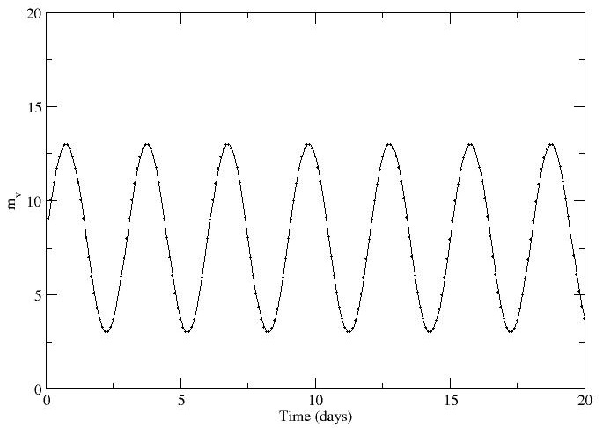
B) What is the average apparent magnitude of the star?

C) What is the period of the change in brightness (the time between adjacent peaks of the curve)?

Introduction: Our understanding of galaxies is partly based on what we've already learned about stars. This understanding will be severely limited if we cannot get accurate distances for these galaxies. In this lab, you will learn about several methods that are used to determine the distances to galaxies.

A. Cepheid variables: Many of our distance methods for galaxies are based on the same spectroscopic parallax that we use for stars. This is based on the following equation which we’ve encountered in previous labs.

m – M = 5 log d – 5
In this equation, m is the apparent magnitude, M is the absolute magnitude (related to its luminosity), and d is the distance to the star in parsecs.

Nearby stars are several parsecs away, but nearby galaxies are several million parsecs (megaparsecs = Mpc) away. It will be helpful to use an equation relating m – M to the distance in Mpc. This equation is:

m – M = 5 log d_{Mpc} + 25

In the "Properties of Stars" lab, the calculations were simplified by using a table, rather than making you use the equation above. A similar table can be found on the lab table, relating m – M to the distance in Mpc. It's also at the following URL. http://natsci.parkland.edu/ast/102/labs/galaxydistance.html

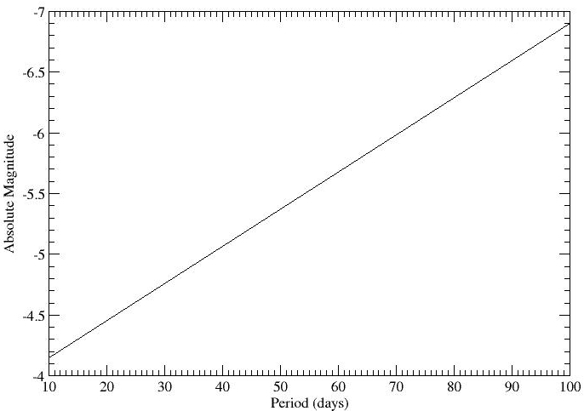
The equation and the table can in principle be used for any kind of object. Unfortunately, main sequence stars like our sun are not bright enough to use for even nearby galaxies. Giant and supergiant stars are much brighter, but in general, they have a fairly large range in brightness.

A class of giant stars called Cepheid variable stars have been found to change in size regularly. Remember that luminosity is related to size, so stars which change size regularly also change brightness regularly.

Most importantly, the rate at which these stars pulsate has been found to be related to their average brightness. This relationship is called the period-luminosity relation and is shown in the figure to the right. Based on this figure, answer the following questions.

1. Describe the relationship between period and luminosity for Cepheid variables.

2. What is the absolute magnitude of the brightest Cepheid variable stars?

3. What is the pulsation period of the brightest Cepheid variable stars?

Let's say that for a Cepheid variable star, you observe its light curve (the way that the brightness of the star varies over time). You will find five light curves on the table in the lab. From these light curves, you can determine the average apparent magnitude and the period of pulsation (the time from peak to peak brightness). If a light curve doesn’t have a complete cycle, you will have to find the period of a half-cycle and multiply by two. Use the period-luminosity relation in the figure on the previous page to find the absolute magnitude. The two magnitudes will help you determine m – M and the m – M vs. distance table will help you complete the following table.

Object | Average Apparent Magnitude | Period (days) | Absolute Magnitude | m – M | Distance (Mpc)
Phe dw
M32
NGC 3109
Argo dw
UGCA 92

The Local Group consists of the Milky Way and all the galaxies within five million light-years of it.

4. Which of the galaxies above are not likely to be members of the Local Group?

5. Let's say that you go looking for Cepheid variable stars using the Hubble Space Telescope, which can see stars with apparent magnitudes of 25. For the brightest Cepheid variable stars (from Question 2), what is the maximum distance these stars can be detected from using Hubble?

Assess whether Cepheid variable stars can be used to determine the distance to the following objects.

 | Large Magellanic Cloud | Andromeda Galaxy | Coma cluster of galaxies
Distance | 160,000 ly | 2.5 million ly | 321 million ly
6. Can use Cepheids?

B. Tully-Fisher relation: Many of the galaxies in the universe are spiral galaxies like our Milky Way. We know that the rotation curve of the Milky Way can be used to determine the way that mass is distributed throughout the galaxy. More recently, two astronomers named Brent Tully and Richard Fisher determined that the rotation curve of a galaxy is also related to the absolute luminosity of the galaxy. Since galaxies are much brighter than even Cepheid variable stars, we expect that this method can be used to much greater distances. The plot on the next page shows the Tully-Fisher relation for a set of galaxies at the same distance.

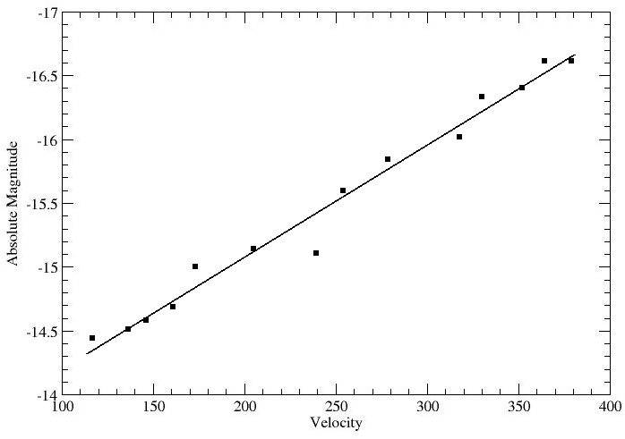
7. Describe the relationship between the rotation velocity of a spiral galaxy and its luminosity.

8. Why would spiral galaxies show this relationship? Think about how the graph shown relates to the mass of the galaxy.

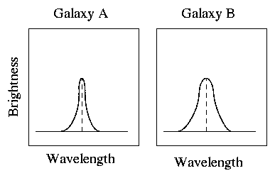
The velocity of the galaxies is determined through the width of the 21-cm emission line. We know from the Doppler effect that the larger the shift in wavelength, the higher the velocity of the object. The figures to the right show the 21-cm emission lines for two different galaxies. The dashed line shows the rest wavelength.

9. Based on the observed emissions, which galaxy has a lower absolute magnitude?

10. If both galaxies in the picture have the same apparent magnitude, which galaxy has a higher value of m – M? Explain your answer.

11. Which galaxy is farther away?

12. Spiral galaxies can have absolute magnitudes as low as -22. If Hubble can see apparent magnitudes of 25, what is the maximum distance these galaxies can be detected from?

Unfortunately, it becomes increasingly difficult to accurately measure the rotation velocity of the galaxy as you look at galaxies father and farther away. Look up the distances of galaxies for which you can use the Tully-Fisher relation in your textbook.

13. Can the Tully-Fisher relation be used for any of the objects in Question 6 for which you could not use Cepheid variable stars? If so, which ones?

