Name: _____________________

Astronomy 102 Lab: Ages of Star Clusters

Pre-Lab Assignment: In class, we learned that different types of stars evolve at different rates. By plotting the H-R diagram for a cluster, we can estimate its age by looking at what kinds of stars are located at the main sequence turnoff. In this lab, you will be using H-R diagrams of several clusters to determine the ages of these clusters. Answer these questions before coming to lab.

A) What happens inside a star that allows it to "move" off the main sequence?

B) What kind of star moves off the main sequence in the least amount of time (mass and temperature)? What spectral class is such a star?

C) Here are simplified H-R diagrams of two star clusters. Which one is older? Explain your answer.

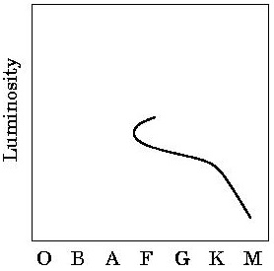
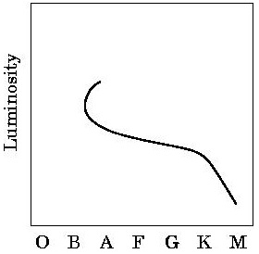
A B

Introduction: We assume that all stars in each star cluster were born at about the same time and have similar chemical compositions. Since stars of different ages evolve at different rates, all stars in a cluster don't fall on the main sequence. In addition to main sequence stars, a cluster may contain stars that are evolving away from the main sequence, such as red giants. In an older cluster, we expect more stars would have had time to evolve off the main sequence; the O and B stars, being the most massive, leave the main sequence first. By finding the turn-off point (that region of the main sequence where the stars are just beginning to evolve towards the red giant region) we can estimate the cluster's age. If you can find the color index, or (B–V) of this turn-off point, we can use a chart to determine the cluster's age.

Basic data: Using your light table, place the color-magnitude diagram for one of the five star clusters over the ZAMS diagram. "ZAMS" stands for "zero age main sequence." Move the cluster's diagram left or right until the color indices (B–V) align. Now slide the cluster diagram only up or down (keeping the B–V scales aligned) until you get the best possible match between the ZAMS and the main sequence of the cluster. Recall hot main sequence stars, having small or negative color indices, leave the main sequence first; be sure that the cooler main sequence stars fall on the ZAMS even if the hotter stars do not.

Reduction: Having matched the ZAMS and the cluster main sequence, find the point where the stars first appear to leave the ZAMS; this is the "turn off point." Choose this point so there are few stars lying to the left of it. Write the (B–V) of this point on your data sheet. Then consult the age chart to determine the age of the cluster. Note that this chart is a "log chart," meaning your answers will appear something like "2.0 × 10⁸ years." Ask your instructor if you have trouble reading this chart.

Data Table: The "NGC" in these names means "New General Catalog" of sky objects.

Cluster | (B–V) of turn-off point | Age (in years)
M45 (Pleiades)
NGC 752
NGC 2632
NGC 6705
NGC 6791

1. Why are the stars leaving the main sequence? What's happening in the core of the star at that time? What's happening in the outer layers of the star at that time?

2. When stars leave the main sequence, what is the name of the region on the HR diagram do they go to? How do these stars compare to the Sun in terms of temperature, radius, and luminosity?

3. What spectral class of star leaves the main sequence last? What is such a star like in terms of mass, temperature, and luminosity?

4. If the turn-off point for a cluster just happened to be right where the G-class of stars were located, how old would the cluster be? (Hint: consider the Sun).

5. In the H-R diagrams you were using in this lab, the vertical axis used the visual or apparent magnitude (m), but in class we always used the absolute magnitude (M) for the vertical axis. How can we get away with using apparent magnitude here? (Hint: What is the mathematical difference between apparent magnitude and absolute magnitude?)

On the first attached graph, make a plot of the HR diagram for a 10-billion-year old cluster.

- Use the age chart to find the B–V value for the main sequence turn-off for the cluster
- Use the ZAMS diagram to find the corresponding absolute magnitude for that B–V value. This will be the position of the turn-off point.
- Determine which stars on the ZAMS will still be on the main sequence after 10 billion years. (Are they above the turn-off point or below it?)
- Determine B–V and M for a couple of those remaining stars on the ZAMS and plot those coordinates on your sheet.
- Draw a smooth curve through all the points you made, stopping at the turn-off point.
Repeat the procedure for a 100-million-year old cluster using the second graph.
